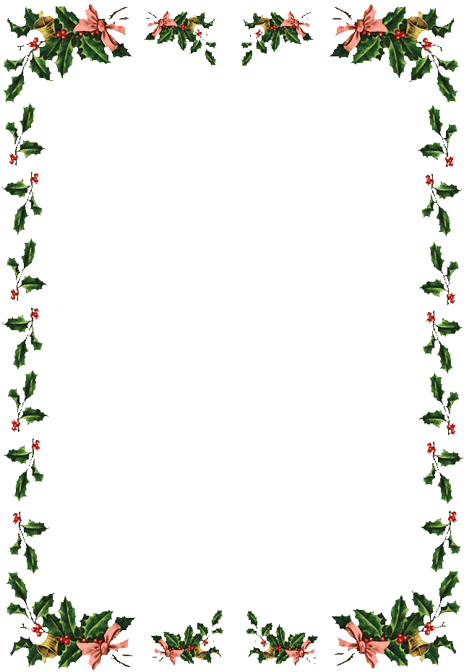
YOU AND YOUR FUR FRIEND
ARE INVITED
TO
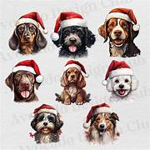
THE OTCH CHRISTMAS PARTY
ON
December 15th from 2PM – 6 PM
AT
The OTCH Building

- Join us for a festive afternoon of food, fun, gifts and games with your dog.
- We will have our pawsome raffle baskets.
- Contact Robin Golberg - rgolberg@comcast.net, by December 10th, to let her know what covered dish you will bring.
- The meat will be provided by OTCH.

Please bring a wrapped gift valued from $10-$15, for a fur friend. Tag it for a small, medium or large dog.

